KROS COLLEGE

LEIRIE: KOHIMA

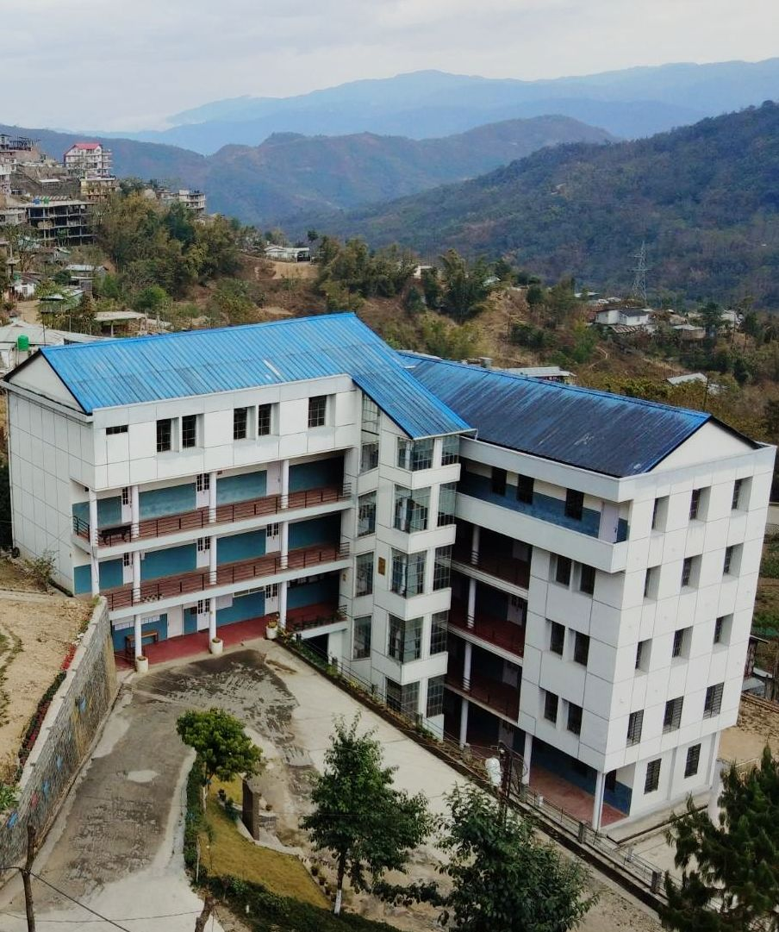

ANNUAL QUALITY ASSURANCE REPORT

(AQAR)

2017-18

Submitted to:

NATIONAL ASSESSMENT AND ACCREDITATION COUNCIL
BENGALURU-560072

The Annual Quality Assurance Report (AQAR) of the IQAC

All NAAC accredited institutions will submit an annual self-reviewed progress report to NAAC, through its IQAC. The report is to detail the tangible results achieved in key areas, specifically identified by the institutional IQAC at the beginning of the academic year. The AQAR will detail the results of the perspective plan worked out by the IQAC. (Note: The AQAR period would be the Academic Year. For example, July 1, 2012 to June 30, 2013)

Part – A
1. Details of the Institution
KROS COLLEGE
1.1 Name of the Institution
LEIRIE
1.2 Address Line 1
P.Box - 679
Address Line 2
KOHIMA
City/Town
NAGALAND
State
797001
Pin Code
kroscollege@gmail.com
Institution e-mail address
09077484549
08794952699
Contact Nos.
Dr. KEKHRIELHOULIE YHOME
Name of the Head of the Institution:
0370-2221259
Tel. No. with STD Code:
09818804474
Mobile:

Mr. Vidilhou Suohu
Name of the IQAC Co-ordinator:

08794866467
Mobile:
Kroscollege@gmail.com
IQAC e-mail address:
NLCOGN 25902
1.3 NAAC Track ID (For ex. MHCOGN 18879)

1.4 NAAC Executive Committee No. & Date:
EC (SC)/27/A&A/69.1 dated 12/September/2017
(For Example EC/32/A&A/143 dated 3-5-2004.
This EC no. is available in the right corner- bottom
of your institution’s Accreditation Certificate)

www.kroscollegekohima.co.in
1.5 Website address:
www.kroscollegekohima.co.in/IQAC/NLCOGN 25902-KROS COLLEGE,LEIRIE-KOHIMA.doc

Web-link of the AQAR:
For ex. http://www.ladykeanecollege.edu.in/AQAR2012-13.doc
1.6 Accreditation Details
Sl. No. | Cycle | Grade | CGPA | Year of Accreditation | Validity Period
1 | 1st Cycle | B | 2.22 | 2017 | 5 years
2 | 2nd Cycle
3 | 3rd Cycle
4 | 4th Cycle

1.7 Date of Establishment of IQAC: DD/MM/YYYY
11/01/2013

2017-2018
1.8 AQAR for the year (for example 2010-11)

1.9 Details of the previous year’s AQAR submitted to NAAC after the latest Assessment and Accreditation by NAAC ((for example AQAR 2010-11submitted to NAAC on 12-10-2011)
- AQAR _______________-N.A-________ __________________ (DD/MM/YYYY)4
- AQAR_______________ -N.A-__ ________________________ (DD/MM/YYYY)
- AQAR______________ _-N.A-___ _______________________ (DD/MM/YYYY)
- AQAR_______________ -N.A-__ _______________________ (DD/MM/YYYY)
1.10 Institutional Status

✓

University State Central Deemed Private
✓

Affiliated College Yes No

✓
Constituent College Yes No

✓
Autonomous college of UGC Yes No

✓
Regulatory Agency approved Institution Yes No
(eg. AICTE, BCI, MCI, PCI, NCI)
✓

Type of Institution Co-education Men Women
✓

Urban Rural Tribal

Financial Status Grant-in-aid UGC 2(f) UGC 12B
✓

Grant-in-aid + Self Financing Totally Self-financing

1.11 Type of Faculty/Programme
✓

Arts Science Commerce Law PEI (Phys Edu)
✓

TEI (Edu) Engineering Health Science Management

Others (Specify)

1.12 Name of the Affiliating University (for the Colleges)
NAGALAND UNIVERSITY

1.13 Special status conferred by Central/ State Government-- UGC/CSIR/DST/DBT/ICMR etc
N.A
Autonomy by State/Central Govt. / University
N.A

University with Potential for Excellence UGC-CPE
N.A

N.A

N.A

DST Star Scheme UGC-CE
N.A

N.A

UGC-Special Assistance Programme DST-FIST
N.A

UGC-Innovative PG programmes Any other (Specify)
N.A

UGC-COP Programmes

2. IQAC Composition and Activities
05
2.1 No. of Teachers
03
2.2 No. of Administrative/Technical staff
01
2.3 No. of students
2.4 No. of Management representatives
01
01
2.5 No. of Alumni
2. 6 No. of any other stakeholder and
03
community representatives

2.7 No. of Employers/ Industrialists

2.8 No. of other External Experts
2.9 Total No. of members
14

2.10 No. of IQAC meetings held
04

20
6
2.11 No. of meetings with various stakeholders: No. Faculty
5+8
01

Non-Teaching Staff /Students Alumni Others
2.12 Has IQAC received any funding from UGC during the year? Yes No

✓✓
If yes, mention the amount
2.13 Seminars and Conferences (only quality related)
(i) No. of Seminars/Conferences/ Workshops/Symposia organized by the IQAC
5

2
3
Total Nos. International National State Institution Level
STATE LEVEL SEMINAR
- “Entrepreneurial Development Programme”
- “Preserving the past: The Role of oral Tradition in Naga History”

Institution Level SEMINAR

- “Demonetisation and impact on Nagaland Economy”
- “Overcoming the fear of public speaking”
- “Article 371(A) “
(ii) Themes

2.14 Significant Activities and contributions made by IQAC
- Quality Control mechanism to maintain and monitor benchmarks in academics, administration,
infrastructure and institutional social responsibility.

- Extending full support and encouraging faculties to undertake research studies and projects.

- Monitoring the academic growth and progress of the students and taking remedial step in places of
deficiencies and concern.

- Developing a Course action Plan to aid the faculties in having an academic roadmap and monitoring
its progress.

- Organising state level seminars, workshop and conferences for respective departments on regular
basis by inviting scholars, academicians and professionals in various fields to speak, deliberate and
interact on various relevant topics that relates to the academic curriculum.

- Introduction of Information and Communication Technology tools into the teaching process.

- Initiating the automation of processes at all levels and department in a phase manner.

- Promoting and encouraging the active participation of students in social activities concerning NSS,
Red Ribbon Clubs, and Women Development as well a social initiatives and programmes like
Swachh Bharat Abhiyan, Blood Donation drives, Anti-tobacco campaign, etc.

- Introduction of new sports, skills and crafts for value addition in the learning process.

- Extending assistance to economically weak communities by setting up of a tutorial centre where
our faculty and staffs provide free of cost tutorials to students below X standard on all weekdays.

- Skills development day introduced and observed every 3rd and 4th Thursday of the month, where our students are trained and taught in various skills and crafts by a group of trained instructors. The finished products are then put on sale to encourage students as well as to contribute to their corpus fund.

2.15 Plan of Action by IQAC/Outcome
The plan of action chalked out by the IQAC in the beginning of the year towards quality
enhancement and the outcome achieved by the end of the year *
Plan of Action | Achievements
Quality education benchmark and value addition to the educational process. | - Co-ordination between HODs and their respective faculty members in setting an academic action plan has given us a roadmap and blueprint to achieve our academic goals.  -Comprehensive educational process with inputs and support from renowned academician, scholars and professional across various fields has added value into our education work processes.  - Seminars, conferences, workshops and presentations of academic papers by scholars, academicians and experts in academic field have enhanced the learning thought process and critical thinking abilities of our faculties as well as students.  - Capacity building and further training of faculties in various relevant academic concerns by trained professionals has enhanced the delivery of quality education.  - Conversion of classrooms into ‘Smart Classroom’ with the latest Information and Communication Technology tools has aided the learning process through the development of quantitative thinking among students.  -Skills development for capacity building among students to nurture and enhance their skills set has contributed to the all round development of our students
Good governance, best management practices in the organizational setup. | -Decentralization of authority by setting up various committees to monitor and evaluate their work processes has resulted in faster response time while dealing with critical issues and concerns.  - Periodic meeting of committees assists the management in receiving necessary feedbacks and chartering future course of action for all necessary concerns.  - Leadership and management training for non teaching staff have helped them stay motivated, identify their core competencies and in the process contributing to the management best practice of the college.  - Transparency in the work process has helped every individual in having a better understanding of their responsibilities towards a particular tasks and assignment.
* Attach the Academic Calendar of the year as Annexure.
Annexure ‘A’ attached
✓

2.15 Whether the AQAR was placed in statutory body Yes No
✓

Management Syndicate Any other body

Provide the details of the action taken
The AQAR was discussed in the IQAC meetings that are held at regular intervals. Discussions on this matter have been taken up at every advisory board level to deliberate and contribute to the AQAR for 2017-18. It was decided upon by the Governing body to submit the AQAR 2017-18 to the NAAC for which the same will be also be uploaded in the College’s Website and published in the Annual Report of the College.

Part – B
Criterion – I

1. Curricular Aspects

1.1 Details about Academic Programmes
Level of the Programme | Number of existing Programmes | Number of programmes added during the year | Number of self-financing programmes | Number of value added / Career Oriented programmes
PhD
PG
UG | 02
PG Diploma
Advanced Diploma
Diploma
Certificate
Others
Total | 02

Interdisciplinary
Innovative

1.2 (i) Flexibility of the Curriculum: CBCS/Core/Elective option / Open options
(ii) Pattern of programmes:
Pattern | Number of programmes
Semester | ✓
Trimester
Annual

✓
✓
✓
✓
1.3 Feedback from stakeholders* Alumni Parents Employers Students
(On all aspects)
✓
✓

Mode of feedback : Online Manual Co-operating schools (for PEI)
(Annexure ‘B’ Attached)
1.4 Whether there is any revision/update of regulation or syllabi, if yes, mention their salient aspects.
Changes are made depending on the direct orders from Parent University

1.5 Any new Department/Centre introduced during the year. If yes, give details.
-N.A-

Criterion – II
2. Teaching, Learning and Evaluation
2.1 Total No. of permanent faculty
Total | Asst. Professors | Associate Professors | Professors | Others
17 | 17
02
2.2 No. of permanent faculty with Ph.D.
2.3 No. of Faculty Positions Recruited (R) and Vacant (V) during the year
Asst. Professors |  | Associate Professors |  | Professors |  | Others |  | Total
R | V | R | V | R | V | R | V | R | V
03
02

2.4 No. of Guest and Visiting faculty and Temporary faculty

2.5 Faculty participation in conferences and symposia:

No. of Faculty | International level | National level | State level
Attended Seminars/ Workshops |  |  | 05
Presented papers |  | 03
Resource Persons

2.6 Innovative processes adopted by the institution in Teaching and Learning:
- Relevant topics and issues beyond the set curriculum are covered to supplement the teaching and learning process.

-Respective departments prepare a Course plan for teaching and evaluation as per the syllabus of respective subject at the beginning of every Semester.

-The faculty members are provided with teaching and evaluation format which contains the course plan to be fulfilled by the faculty member.

- The concerned Head of the Department conducts meeting with all the faculty members and allots subjects based on their expertise.

-Course-coverage is monitored by the HOD and the progress on the same reported to the Vice- Principal and Principal.

- Remedial classes are provided for the students to clear their doubts and the difficulties faced with regard to any subject or topics in the curriculum.

- Continuous monitoring and evaluation conducted at regular intervals to assess the progress made and to take corrective measures in case of deviation from the set course plan.

- Integration of Information and Communication Technology tool into the regular and traditional teaching process.

-Innovative mindset inculcated in the thought process of educators and recipients of the learning work process.

-Finding innovative solutions to overcome barriers in the learning process.

-Finding new channels to simulate the intellectual thought process to stimulate the creative vision of our students.

-Innovative teaching process through audio/visual aids.

- Learning based on solving real life problems and processing of information in innovative ways to positively impact the intellectual though process.

2.7 Total No. of actual teaching days
120 Days
during this academic year

2.8 Examination/ Evaluation Reforms initiated by
Open Book evaluations and double evaluations every Semester
the Institution (for example: Open Book Examination, Bar Coding,
Double Valuation, Photocopy, Online Multiple Choice Questions)

N.A

2.9 No. of faculty members involved in curriculum
restructuring/revision/syllabus development
as member of Board of Study/Faculty/Curriculum Development workshop

80%
2.10 Average percentage of attendance of students

2.11 Course/Programme wise
distribution of pass percentage :

Title of the Programme | Total no. of students appeared | Division
Title of the Programme | Total no. of students appeared | Distinction % | I % | II % | III % | Pass %
UG | 31 | 13% | 64.5% | 9.6% |  | 75%

2.12 How does IQAC Contribute/Monitor/Evaluate the Teaching & Learning processes:
-The IQAC regularly monitors and assess the progress made in teaching and learning process
as per the academic plan set at the beginning of every semester.

-The IQAC also encourages the faculties as well students to give high importance and
concentration on research based studies so as to inculcate an environment of scholastic
research based learning.

-The IQAC extends full support to all departments to conduct workshops, seminars,
conferences and presentation of academic paper to add value to the education learning
process for the faculties as well as the students.

-The IQAC provides financial assistance to carry out research based studies as well as
publication of academic papers in various academic journals of repute.

-The IQAC gives immense importance in developing a learning process that encourages
innovation, creativity, team spirit and entrepreneurial leadership in our students.

2.13 Initiatives undertaken towards faculty development
Faculty / Staff Development Programmes | Number of faculty  benefitted
Refresher courses
UGC – Faculty Improvement Programme
HRD programmes | 01
Orientation programmes
Faculty exchange programme | 01
Staff training conducted by the university
Staff training conducted by other institutions
Summer / Winter schools, Workshops, etc.
Others

2.14 Details of Administrative and Technical staff
Category | Number of Permanent  Employees | Number of Vacant  Positions | Number of permanent positions filled during the Year | Number of positions filled temporarily
Administrative Staff | 16 | NA | NA | NA
Technical Staff | 03 | NA | NA | NA

Criterion – III
3. Research, Consultancy and Extension
3.1 Initiatives of the IQAC in Sensitizing/Promoting Research Climate in the institution
- Leveraging educational best practices to create an ecosystem of research oriented thought
process in our education.

- Investments in research based on the insights of our unique qualities and abilities in our
education work process, and identifying niche areas for capacity building to substantiate
and add value to our research climate.

- Increase level of participation based on quantitative learning process to aid our research
based educational work systems.

- Research collaboration between individual researches to strengthen the quality of research.

- Adapting and evolving our education process continually to sensitize on our preparedness
for conducting researches at regular intervals

3.2 Details regarding major projects
 | Completed | Ongoing | Sanctioned | Submitted
Number | NA | NA | NA | NA
Outlay in Rs. Lakhs

3.3 Details regarding minor projects
 | Completed | Ongoing | Sanctioned | Submitted
Number | NA | NA | NA
Outlay in Rs. Lakhs

3.4 Details on research publications
 | International | National | Others
Peer Review Journals |  |  | 02
Non-Peer Review Journals |  |  | 03
e-Journals
Conference proceedings

3.5 Details on Impact factor of publications:

✓

Range Average h-index Nos. in SCOPUS

3.6 Research funds sanctioned and received from various funding agencies, industry and other organisations
Nature of the Project | Duration  Year | Name of the  funding Agency | Total grant  sanctioned | Received
Major projects | NA
Minor Projects | NA
Interdisciplinary Projects | NA
Industry sponsored | NA
Projects sponsored by the University/ College | NA
Students research projects  (other than compulsory by the University) | NA
Any other(Specify) | NA
Total | NA

3.7 No. of books published i) With ISBN No. Chapters in Edited Books
NA
NA
NA
ii) Without ISBN No.
3.8 No. of University Departments receiving funds from
NA
NA
UGC-SAP CAS DST-FIST
NA
NA
NA
DPE DBT Scheme/funds
3.9 For colleges Autonomy CPE DBT Star Scheme
NA
NA
NA
INSPIRE CE Any Other (specify)
NA
NA
NA
NA
3.10 Revenue generated through consultancy
Level | International | National | State | University | College
Number
Sponsoring agencies
3.11 No. of conferences
organized by the Institution
02
3.12 No. of faculty served as experts, chairpersons or resource persons
NA
NA
NA
3.13 No. of collaborations International National Any other
NA
3.14 No. of linkages created during this year

3.15 Total budget for research for current year in lakhs :

0.80 lakhs
From Funding agency From Management of College
Total
0.80 lakhs

3.16 No. of patents received this year
Type of Patent |  | Number
National | Applied | NA
National | Granted | NA
International | Applied | NA
International | Granted | NA
Commercialised | Applied | NA
Commercialised | Granted | NA

3.17 No. of research awards/ recognitions received by faculty and research fellows
Of the institute in the year
Total | International | National | State | University | Dist | College
NA | - | - | - | - | - | -

3.18 No. of faculty from the Institution
NA
who are Ph. D. Guides
and students registered under them
NA

3.19 No. of Ph.D. awarded by faculty from the Institution
NA

3.20 No. of Research scholars receiving the Fellowships (Newly enrolled + existing ones)

JRF SRF Project Fellows Any other

03

3.21 No. of students Participated in NSS events:
01
35
University level State level
National level International level

3.22 No. of students participated in NCC events:
NA

University level State level
National level International level

3.23 No. of Awards won in NSS:
03
University level State level

National level International level

3.24 No. of Awards won in NCC:
University level State level
NA
NA NA
National level International level
NA
NA

3.25 No. of Extension activities organized

University forum College forum

03

NCC NSS Any other

3.26 Major Activities during the year in the sphere of extension activities and Institutional Social
Responsibility
- Community cleanliness drives under ‘Swachh Bharat Abhiyan’ initiative.
- Disaster management mitigation by creating community awareness and extension of assistance in areas affected by environmental disasters.
- Community outreach by visiting and interacting with inmates lodged in nearby prisons.
- Participation in Blood Donation Drive under the initiative of the Red Ribbon Club.

Criterion – IV
4. Infrastructure and Learning Resources
4.1 Details of increase in infrastructure facilities:
Facilities | Existing | Newly created | Source of Fund | Total
Campus area | 5 Acres |  |  | 5 Acres
Class rooms | 20 |  |  | 20
Laboratories
Seminar Halls | 01 |  |  | 01
No. of important equipments purchased (≥ 1-0 lakh) during the current year.
Value of the equipment purchased during the year (Rs. in Lakhs) | 1.5 lakhs |  | Fees/  Grant in Aid
Others

4.2 Computerization of administration and library

ICT tools with internet connectivity are being integrated into our education systems.

- Complete computerization in the administrative and academic level.

- The library is fully digitized with the aid of KOHA software to create an
effective management information system of its available resources.

4.3 Library services:
 | Existing |  | Newly added |  | Total
 | No. | Value | No. | Value | No. | Value
Text Books | 483 | 501268 | 72 | 27932 | 555 | 529200
Reference Books | 1024 | 696663 | 113 | 34137 | 1137 | 730800
e-Books
Journals | 10 | 33000 | 10 | 45000 | 20 | 78000
e-Journals
Digital Database
CD & Video
Others (specify)

4.4 Technology up gradation (overall)
 | Total Computers | Computer Labs | Internet | Browsing Centres | Computer Centres | Office | Depart-ments | Others
Existing | 35 |  | 35 | 6 | 16 | 3 | 6 | 4
Added | 14 |  | 14 | 2 | 4 | 4 | 1 | 3
Total | 49 |  | 49 | 8 | 20 | 7 | 7 | 7

4.5 Computer, Internet access, training to teachers and students and any other programme for technology
upgradation (Networking, e-Governance etc.)
-Computer and internet access is provided to the students for their educational purposes.

-Free Wi-Fi campus

4.6 Amount spent on maintenance in lakhs :
275465
i) ICT
1160445
ii) Campus Infrastructure and facilities
130299
iii) Equipments

iv) Others

1566209
Total :

Criterion – V
5. Student Support and Progression
5.1 Contribution of IQAC in enhancing awareness about Student Support Services

- Student Council to represent the needs and concerns of the students and to create a co-ordinated network between students, faculties and management.

- Workshops, seminars and conferences are held at regular intervals to deliberate on relevant issues and also for capacity building of our students in skills development, career guidance and community awareness.

- Awards for academic excellence to encourage and motivate the student to bring out their competitive spirit and also to instil in them the importance of determination, perseverance and hard work.

-Classroom upgraded to smart classrooms to aid student learning with the latest audio/visual support which has become an intrinsic component in modern learning process.

-Active participation in NSS, Red Ribbon Club activities to encourage student to take part in community development activities.

-Women Development Cell to empower female students and faculty members.

-Skills development to tap the innate skills and abilities of our students by introducing the training of various craft and skill learning activities by well trained and experienced instructors.

- Alumni Association to create strong professional and social networks.

5.2 Efforts made by the institution for tracking the progression
-Keeping track of the academic progress of every individual student.

-Periodic departmental reports and co-ordination meetings for a structured academic roadmap.

-Creating a focused group of students who are lagging in their academic progress.

- Regular Academic audit at the end of every semester to monitor the progress of academic curriculum.

-Internal Audit is conducted every year to assess the progress made in internal quality control and achievable targets and objectives set for the academic year.

- Financial support and assistance towards researches.

-Experts and professional in the field of academia, business, public service, health service and civil service are invited to advise and interact with our students for their future career progression.

-Regular seminars on various topics are held with research papers and journals being presented by scholars and academician.

-Introducing new sports and crafts to enable creative capacity building.

5.3 (a) Total Number of students
UG | PG | Ph. D. | Others
206

(b) No. of students outside the state
10
0
(c) No. of international students

Men Women
No | %
114 | 55.33
No | %
92 | 44.67
Last Year |  |  |  |  |  | This Year
General | SC | ST | OBC | Physically Challenged | Total | General | SC | ST | OBC | Physically Challenged | Total
02 | 02 | 197 | 04 | 01 | 206 | 04 | 01 | 196 | 03 | -- | 203
Demand ratio 1:1 Dropout % 04%
5.4 Details of student support mechanism for coaching for competitive examinations (If any)
- Professionals from various Govt. Sector such as administration, police, legal experts, banking and financial institution are invited to advise and encourage our students to navigate the rigours of preparing for competitive exams.

- Interactions and discussions between students to keep themselves up to date with current prevalent events and issues.

- Local and national dailies, weekly current affairs journals and magazines, general awareness and aptitude guide books, yearly current affair books, study materials across subjects with syllabi that revolve around competitive exams are made available to the students through our library.

-Personality development training through trained instructor to prepare and guide our students to face interviews and screening process of competitive exams.
-Under skills development programme of the college, coaching classes for competitive exams are imparted.

50
No. of students beneficiaries
5.5 No. of students qualified in these examinations

NET SET/SLET GATE CAT
IAS/IPS etc State PSC UPSC Others

01

5.6 Details of student counselling and career guidance
-Professionals across academia, business, govt sector, banking and financial institutions, music and arts, sportsperson, craftsman, etc are invited to motivate, interact and encourage our students to identify their capabilities and talents to choose the right career path.

-A high priority on skills development to enable students to identify their talents and nurture it to its true potential.

-Support from the faculty and management in guiding our students with career oriented focus in teaching and counselling.

- A big focus on the importance of work culture and work ethics is being instilled in the mindset of our students.

-Job Fairs by reputed organizations to open the doors for employment.

05
No. of students benefitted

5.7 Details of campus placement
On campus |  |  | Off Campus
Number of Organizations Visited | Number of Students Participated | Number of Students Placed | Number of Students Placed
02 | 65

5.8 Details of gender sensitization programmes
- A fully functional Women Development Cell.

-Seminars on gender sensitization and awareness by social entrepreneurs and organizations in the field of gender equality.

-Increase outreach and awareness though our education work process to create an environment that fosters equal treatment.

5.9 Students Activities
5.9.1 No. of students participated in Sports, Games and other events
08

State/ University level National level International level

No. of students participated in cultural events
01

State/ University level National level International level

5.9.2 No. of medals /awards won by students in Sports, Games and other events

Sports : State/ University level National level International level
01

Cultural: State/ University level National level International level

5.10 Scholarships and Financial Support
 | Number of  students | Amount
Financial support from institution | 24 | 116000
Financial support from government | 123 | 1599000
Financial support from other sources
Number of students who received International/ National recognitions

5.11 Student organised / initiatives
NA
NA
NA
Fairs : State/ University level National level International level
NA
NA
NA
Exhibition: State/ University level National level International level
32
5.12 No. of social initiatives undertaken by the students

5.13 Major grievances of students (if any) redressed: _____- N.A-__________________________

Criterion – VI
6. Governance, Leadership and Management
6.1 State the Vision and Mission of the institution
Vision
-To be a major Centre for Education, Workforce Teaching, Partnerships and Economic Development.
Mission
-To provide innovative education, opportunities, and experience that enables individuals, communities and the region to grow, thrive and prosper.

6.2 Does the Institution has a management Information System
The Institute has a Management Information System and aids the following processes:
- Admission Process
- Fees statement and records
-Academic Records
-Tabulation of Exam related marks and results
-Attendance Record
-Library Information system
-Feedback management system

6.3 Quality improvement strategies adopted by the institution for each of the following:
6.3.1 Curriculum Development
- Adding further academic supplements beyond prescribed curriculum to build capacity and increase the all round intellectual thought process and awareness of our students.
- Course development that is quantitative in nature to enable practicality, creativity and clarity in the education work processes.
- Case studies to understand the relevancy of the curriculum with real and relevant issues and topics.
- Addition of external and relevant study materials to supplement the existing curriculum.

6.3.2 Teaching and Learning
- Innovative teaching methods with audio and visual aids.
-Smart Classrooms to integrate Information and Technology in the education systems.
-Special tutorial and remedial classes to cover topics that further supplement and add value to the existing curriculum.
-Field trips, educational tours, on-site training to complement the existing curriculum
- Presentations, reports and academic papers to enable further clarity in the learning process.
- Group discussions and interactions of relevant topics and issues that relates to the curriculum being taught.

6.3.3 Examination and Evaluation
- Unit tests
-Presentations of various topics in the curriculum
-Written assignments
-Project Reports
-Group discussions
-Case Studies
-Mid-term evaluation Exams
-Semester Exams

6.3.4 Research and Development
- Adequate funds allocated annually for research.
- Presentation and publication of academic papers in various journals.
- Integration of classroom learning to research modules to create a research oriented environment.
- Training and workshops in report writing, collection of data, conducting surveys, data analysis, scholastic writing skills, etc.
- Students are given assignments in various topics that are research oriented with an intention to inculcate a scholastic mindset for future involvement in research studies.

6.3.5 Library, ICT and physical infrastructure / instrumentation
- Library management using KOHA software.
- Periodic update of library with books, journals, papers, educational software to keep up to date with the latest in academic infrastructure.
- Conversion of classrooms in to ‘Smart Classrooms’ with the latest audio/video visual aids and Information and Communication technology tools.
- Regular update and purchase of Information and Communication Technology tools and equipments.

6.3.6 Human Resource Management
- A well laid out framework with regard to human resource management is in place with a well defined hierarchy and service rules.
- Professionally managed with well laid out recruitment, selection and induction process of faculties as well as non-teaching staffs.
-Provisions made for guest faculties, trainers and instructors to assist on need basis.
- For student issues and grievances, a student council is in place to represent the student body to bring to the notice such issues and to find a solution in consultation with the management.

6.3.7 Faculty and Staff recruitment
- A selection committee is constituted based on the requirement and vacancy of post.
- Advertisements are sent out to local and national dailies with an invitation to apply and fill up the vacant posts.
- A panel comprising the head of institution, management and subject specialist from the parent university is formed to conduct the recruitment process.
- Applicants are selected transparently as per the laid down UGC norms.

6.3.8 Industry Interaction/Collaboration
- Partnership with social and governmental organization that hosts our students regularly to acquaint them with their activities that corresponds to the subject matter being taught in the curriculum.
- Jobs Fair conducted in campus by reputed organizations to identify potential students for post studies employment.
- Interaction and workshops by professionals in various fields to enable and create awareness in our students to indentify their true interests, potential and expertise.
- Summer training of our students with partner organizations.

3.8 Industry Interaction / Collaboration

6.3.9 Admission of Students
- Advertisement for new admissions in local dailies, web site.
- Screening based on the applicant student’s academic records.
- Personal interview for selected students.
- Selection based on performance in interview and allocation of seats based on the number of seats proposed per course.
- Seats reserved for students of economically backward communities, People with Disabilities (PwD),and ST SC as per laid down rules and regulation of the Government.

6.4 Welfare schemes for
Teaching | -Provident funds and Pension schemes  -Financial assistance for Research  -One time grant for further studies  -TA/DA for attending seminars, workshops, conferences etc.
Non teaching | -Provident funds and Pension schemes  -Living quarters for accommodation  - Concessions in remitting the payment of fees for their children.
Students | - Awards for meritorious students.  -Assistance in availing scholarships being granted by the  Government.  - Concessions in remitting the payment of fees for students from economically backward communities.  - Schemes for financial assistants of student hosteller under the Ministry of Tribal Affairs.  - Vocational training  - TA/DA for attending competitions, seminars, conferences, etc.

6.5 Total corpus fund generated
NA

6.6 Whether annual financial audit has been done Yes No
✓

6.7 Whether Academic and Administrative Audit (AAA) has been done?
Audit Type | External |  | Internal
Audit Type | Yes/No | Agency | Yes/No | Authority
Academic | Yes | Nagaland University | Yes | IQAC
Administrative |  |  | Yes | Administrator

6.8 Does the University/ Autonomous College declare results within 30 days?
✓

For UG Programmes Yes No

For PG Programmes Yes No

6.9 What efforts are made by the University/ Autonomous College for Examination Reforms?
-Affiliated college under Nagaland University.
-All binding concerns issued by the University are strictly adhered with.
-Internal examination committee formed to evaluate examination system and performance.
- Midterm exams conducted and no leniency to non-performers in the term exams.
-Debarment of student who haven’t cleared the term exams in sitting for the University Semester Exams.

6.10 What efforts are made by the University to promote autonomy in the affiliated/constituent colleges?
- Binding instructions tweaked at regular intervals to give autonomy to affiliated colleges to improve their respective academic as well as administrative performances.

6.11 Activities and support from the Alumni Association
- Yearly annual Alumni Day celebration
- A well co-ordinated Alumni network has been established using social media instruments to connect and provide regular updates on the activities of the Alumni Association as well as the college.
- Guidance and support to current students on higher education and employment opportunities.
- Physical, financial assistance and moral support to student welfare activities.
- Creating a network with current students to support and create a community of enrichment and empowerment in all aspects of student life and beyond.

6.12 Activities and support from the Parent – Teacher Association
- PTA meetings are conducted at the end of every semester.
- Presentation of departmental activities, extracurricular activities and the overall performance of the college are discussed with the parents.
- Evaluation and feedback of students academic as well as all round performances with their respective parents.
- Open interaction with the parents to address their grievances and concerns with a strong feedback mechanism being incorporated to address such issues.
- Strong network of support rendered by the PTA towards the college in individual capacity as well through the representation of the Association as a whole.

6.13 Development programmes for support staff
- Computer Awareness and Literacy programmes for non-teaching staffs.
- Seminars and workshop by mental health professionals to deal with the challenges and stress related factors associated with work environment.
-Regular capacity building training.

6.14 Initiatives taken by the institution to make the campus eco-friendly
- Rain water harvesting infrastructure for self sustenance.
- Organic Compost Manure Unit to utilize and reduce waste materials.
- Tree Plantation Drives.
- Lush green campus maintained by a dedicated team of maintenance staff.
- Tobacco free campus
- Well planned drainage and sewage system to ensure cleanliness throughout the year.

Criterion – VII
7. Innovations and Best Practices
7.1 Innovations introduced during this academic year which have created a positive impact on the
functioning of the institution. Give details.
- Use of Information & Communication Technology tools in the teaching and learning process.
- Monitoring progress of individual students through a management information system that monitors individual academic performances and participation in activities and providing remedial support to those lacking behind.
- Individual capacity building in personality development, communication skills and personal grooming by trained professionals
- Skills development through weekly vocational training in various skills, crafts and tertiary training of tools and machines.

7.2 Provide the Action Taken Report (ATR) based on the plan of action decided upon at the
beginning of the year

Action Planned | Action Report
Strengthening the teaching and learning process | - ‘Smart Classrooms’ introduced with ICT tools to enhance the teaching and learning process.  - Comprehensive audit of all academic processes  - Action plan introduced at the beginning of every semester for each and every department to have a roadmap and blueprint in delivering the academic work process.  - Increase in the number of seminars, workshops by scholar and academicians to add strategic inputs into the curriculum and increase the intellectual thought process of faculties and students.  -Field and study trips to enable practical learning process.  - As per the instruction given, faculties are to refer to quality content from various outside sources corresponding to their subject topics so as to elevate their teaching knowledge and process. Assistance and support is being given to the faculties to source any external study materials of relevance
Introduction of new skills and sports | - Introduction of new skills like traditional ‘Murah’ making, pickling and food preservation, basket making, wood crafts, calligraphy, masonry, carpentry and traditional handloom.  - Sepak Takhraw which is a sport gaining in popularity in recent times has been introduced with training and coaching from state-level coaches  - Futsal being introduced to tap to the talents and skills of footballers among our students.
Community Outreach | - Partnership with Nagaland State AIDS Society (NSACS) in organizing International Youth Day to spread the awareness on issues associated with AIDS.  - Community cleaning and social work in various localities under the Swachh Bharat Abhiyan initiative.  - Blood Donation drive under the initiative of the Red Ribbon Club  - Tutorial Centre introduced for students from economically backward communities. About 50 enrolments with high priority tutorial in subjects such as Mathematics, Hindi and Science.
Quality and sustainable work and study Environment | - Maintaining a high quality and sustainable infrastructure to ensure quality work and study environment.  - A very friendly, amicable and informal working environment is being encouraged to foster a healthy working relationship between management, faculties, staffs and students.  - Counselling and discussion on mental health issues by trained professionals at regular intervals for both staffs and students to create an awareness on mental health and the steps to be taken to navigate and cope with such concerns and issues.

7.3 Give two Best Practices of the institution (please see the format in the NAAC Self-study Manuals)
- Importance on Research driven teaching and learning

- Importance in community outreach and partnership

Annexure ‘i’ attached

7.4 Contribution to environmental awareness / protection
- Tree Plantation drives.
- Tree saplings of wide variety has been planted all over the campus with proper designated nameplate with their local and scientific names
- High priority in maintaining the quality of our green campus
- Cleanliness drives at regular intervals.
- Segregation of waste and utilization of the organic waste in the in-house bio compost unit to produce sustainable and organic manure.

✓

7.5 Whether environmental audit was conducted? Yes No

7.6 Any other relevant information the institution wishes to add. (for example SWOT Analysis)
Strengths
- Lush, green and spacious campus providing a conducive environment for studies.
- Dedicated and committed faculties and non-teaching staffs.
- Infrastructure, manpower and expertise to host any event, workshop, seminar and conference.
- Healthy working relationship between management, faculties, staffs and students.
- Strong Community Partnership.
- Strong Emphasis and support by the management towards research based studies.
- Participative management of all stakeholders in the decision making.
- Hostel Facilities for both Men and ladies.
- Infrastructure and amenities to create a amicable working and learning environment
- Green initiative to make the campus environmentally sustainable.
Weaknesses
- Low Enrolment of students
- Permanent affiliation under Nagaland University still under process and awaited.
- Potential, competencies and best practices of the college has still not been able to penetrate the wider audience.
Opportunities
- Permanent affiliation in the next few months will open more doors of opportunities.
-Increasing the enrolment of students.
- A number of faculties undertaking research studies and projects.
- Adequate land for future infrastructural development.
- Partnership with community, government and organizations to enable capacity building and add value at all levels of our work process.
- Introducing a full-fledged Vocational Centre to enrich the skills of our student for enrichment and enhancement in their livelihood prospects.
- A strong talent pool of students in various arts and sports discipline.
Threats
- Growing competition from a number of colleges.
- Retention of quality and dedicated faculty and staffs.

8. Plans of institution for next year
- Permanent Affiliation from Nagaland University
-Obtain UGC recognition under Section 2f &12b to become eligible for Govt. Funding.
- Increasing the enrolment of students.
-Encourage more research activities among the faculties
-Re-orient our educational and learning process to continuously produce positive outcome.
-Identify and add to the infrastructural inadequacies.
- Organize more State Level Seminars on various subject matters.
- Create more awareness about the competencies and best practices of the college.
- Add more skills and sports to tap the talents of our students.
- Set the initial blueprint and roadmap for setting up a full fledged Vocational Centre.

Name Mr. VIDILHOU SUOHU Name Dr. KEKHRIELHOULIE YHOME

_______________________________ _____________________________
Signature of the Coordinator, IQAC Signature of the Chairperson, IQAC


_______***_______

“Annexure A”
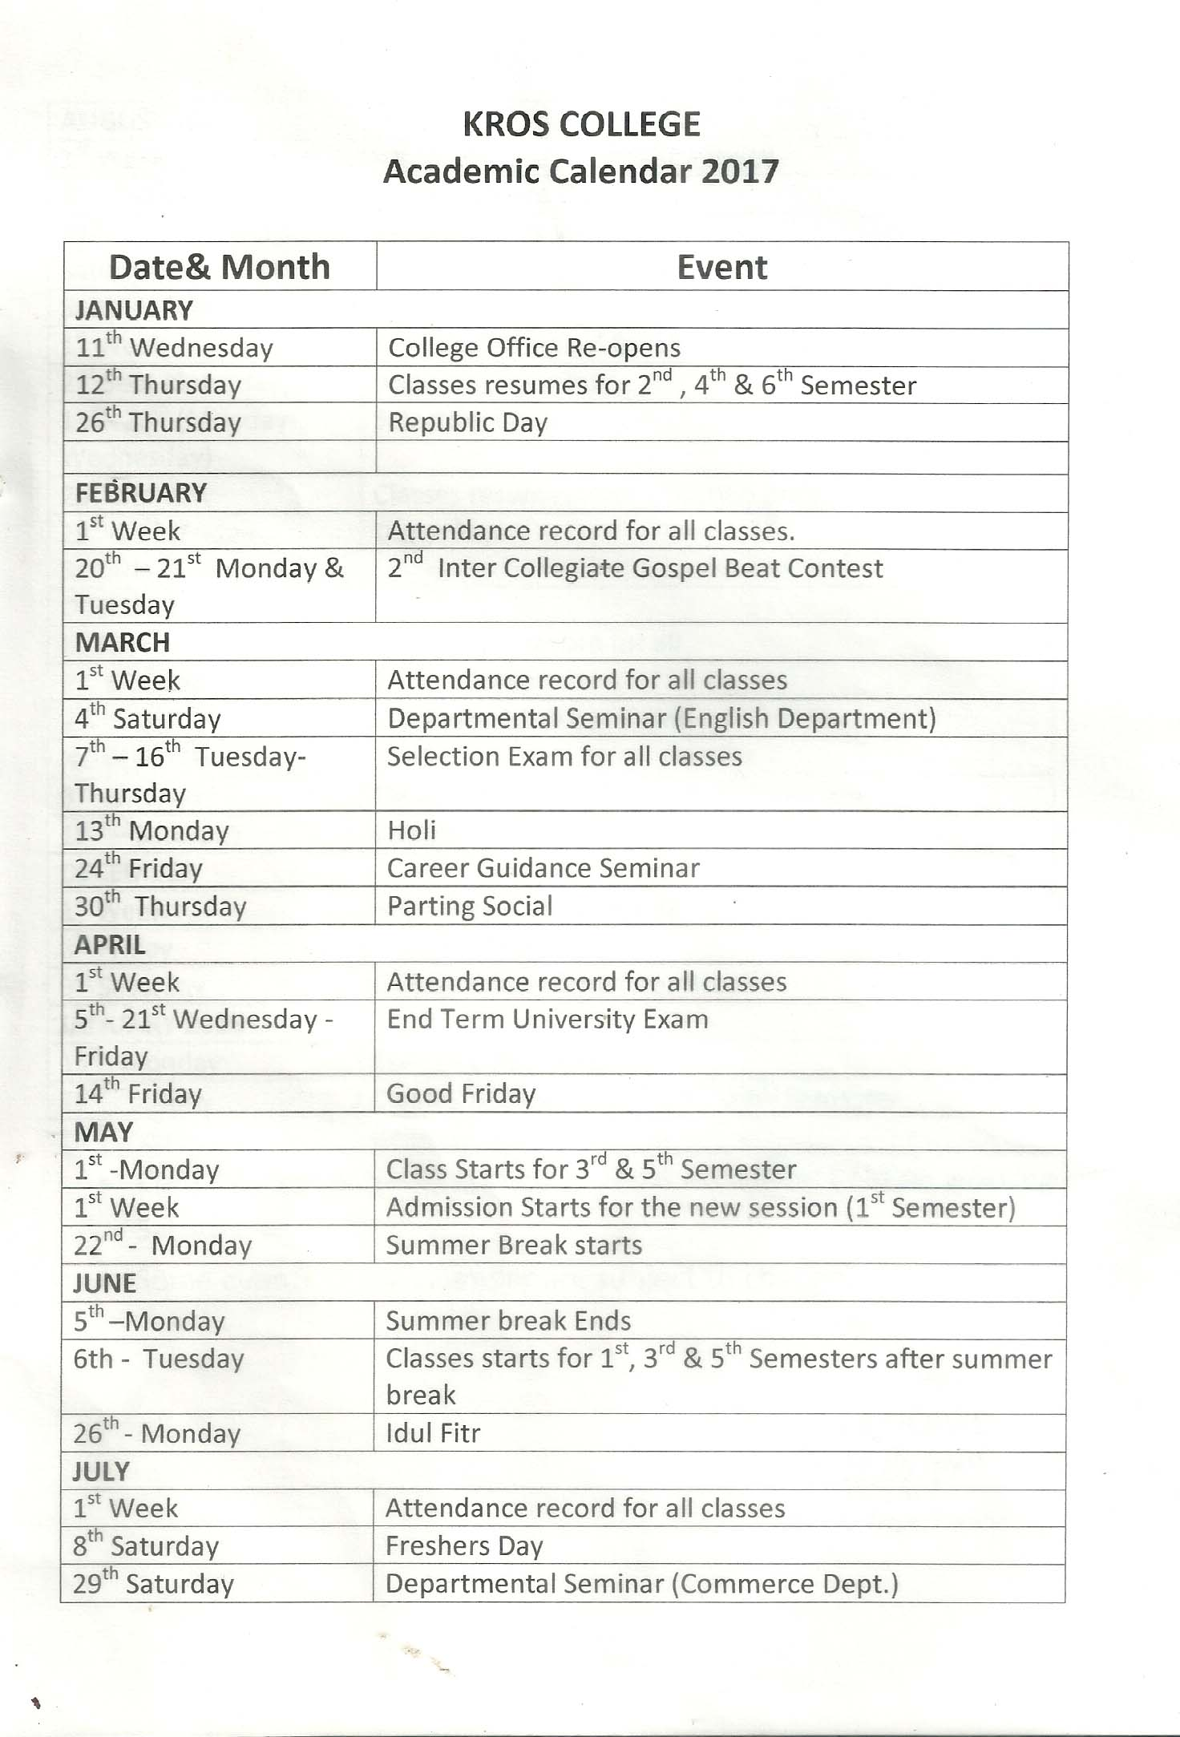

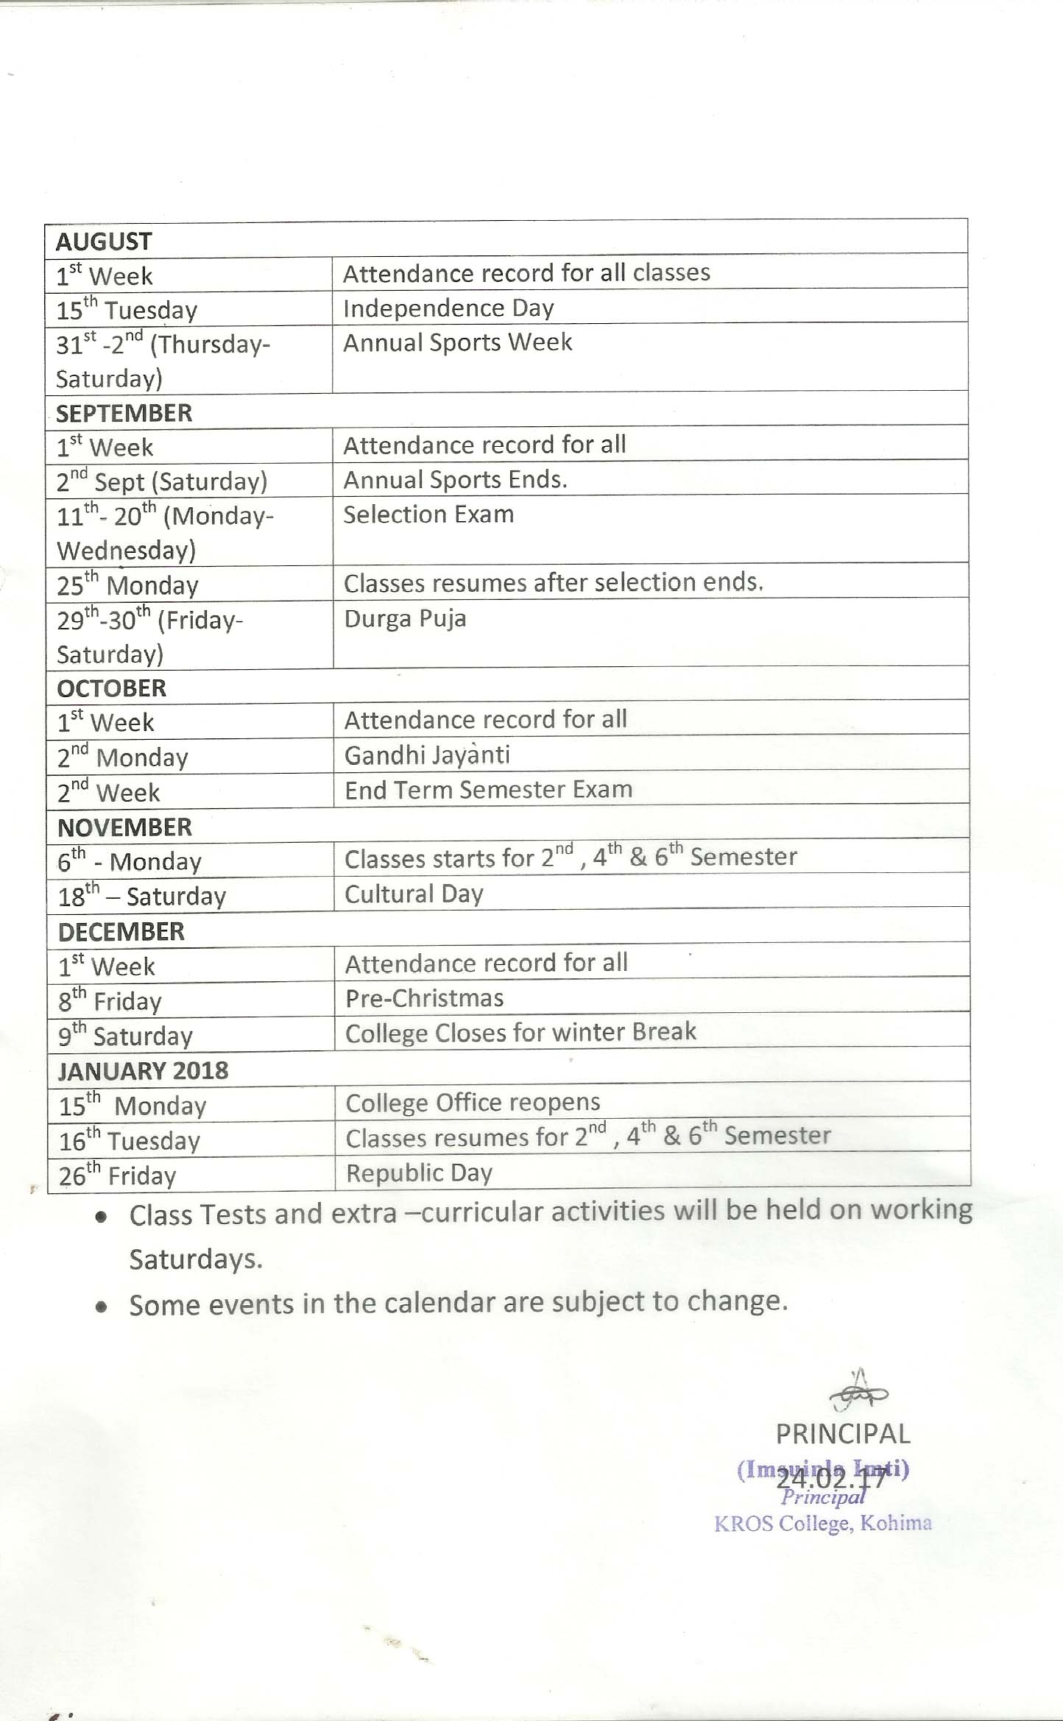

“ANNEXURE B”

Feedback from stakeholder:

ALUMNI
Mode of Feedback- Online

-The Alumni pressed on the need for a strong network of support system between the college and the Alumni Association to establish a medium of co-operation and support from both ends.

-The Alumni Association initiated the extension of support to the college in any possible way though activities and events that add value to the education processes of the College.

The IQAC based on the feedbacks of it Alumni took the initiative in setting up a system of network with the aid of social media instruments to create a strong and integrated chain of communication and interaction with its Alumni. The College has also initiated in taking the assistance of its Alumni through their extension of support in activities and events where their competencies and expertise are put in good service.

PARENTS
Mode of Feedback- Online and Manual

-The Parents sought for more regular meeting of the PTA and regular updates of their ward’s progress.
- A more effective and efficient PTA was pressed upon by the parents.

The IQAC based on the feedbacks of the parents has initiated in further strengthening the existing PTA. The PTA has been reconstituted with the increase in the number of parents in the PTA board as well as the equal representation of the College authorities and the Management of the College. The PTA which was earlier held once yearly is now being held twice a year at the end of every semester with regular updates on the student’s progress every mid-term of the semester. A more inclusive and constructive interaction with the PTA is being put to in place to enable the integration of positive feedback into our system while at the same time working and making certain course correction on their concerns and issues.

EMPLOYERS
Mode of Feedback- Manual

- The employers pressed on the need for further initiative in research and projects that will increase the intellectual capacity and capability of the students.

- The IQAC has been asked to continue with its positive initiatives in the progress of the college while at the same time taking a more pro-active role in introducing new initiatives and projects that will add value to the learning and teaching process.

- The IQAC has been requested to make an accurate estimate and budget outlay for one full academic year so that the amount sanctioned can meet the requirement for one full year without any mid-term revision on the sanctioned budget.

Based on the feedback of the employers, the IQAC has taken the initiative to work and prepare an annual budget outlay for one full academic year so as to prevent any deficit of budget mid-term. A calendar of events has been prepared for one full academic year to break up the budget requirement as per the events to be organized and also to formulate a cohesive budget outlay for one full academic year. An increase in the number of academic seminars, conferences, workshops as well as skill enhancement activities has been organized at regular intervals to enhance the competencies and abilities of the students.

STUDENTS
Mode of Feedback- Online and Manual
- The students seek further strengthening of the Student Council with more Committees to look after various initiatives and activities.
- The Students seek for more co-ordination between the management, faculties and students.
- More skill enhancement activities and initiatives to enhance and explore their innate skills and activities.
- A comprehensive course plan to provide an academic roadmap for the whole academic term.

Based on the student’s feedback, a number of Committees has been constituted to bring better co-ordination in the functioning of the Student Council Body. A pro-active mechanism of interaction with the College authorities and management has been incorporated to address issues and concerns of the students. New skills based activities has been introduced to enhance the skills set of the students. The Academic Heads has been instructed to charter a functional course plan for the full academic term to aid the systematic learning of the students.

ANNEXURE ‘i ’

Two Best Practices of the Institution:
- Importance on Research driven teaching and learning
- Providing Study Leaves to Faculty for pursuing their PhD
- One-time financial grant given to faculties pursuing further studies.
- Yearly budget outlay for assistance towards publications of research papers and projects.
- Faculties and students are encouraged to participate in seminars and workshops at other institutes of higher learning
- Faculties and students are encouraged to participate in capacity building training being organized by Governmental bodies as well as private organizations.
- Hosting of state level seminars by inviting scholars and academicians to present their research papers and studies.
- Publication of paper on various academic journals of repute.

- Importance in community outreach and partnership
- Social initiative drives conducted at regular intervals to spread, propagate and create awareness on various social issues such as AIDS, Health Epidemics, Disaster Management, Environmental Protection, etc.
- Donation of clothes and food material to Old Age Homes, Orphanages, as well as to affected people in displaced areas due to natural calamity and environmental disaster.
- Various activities carried out in the community through initiatives like Swachh Bharat Abhiyan, Blood Donation Drives, Women Empowerment as well as activities associated with the NSS.
- Tutorial Centre for student from economically backward communities.
- Strong partnership and association with parents through the initiatives of the Parents Teachers Associations.

